***Credit Card Fraud Detection***

***Name : Alagimeenal D***

***Register no : 912721104006***

# import the necessary packages

import numpy as np

import pandas as pd

import matplotlib.pyplot as plt

import seaborn as sns

from matplotlib import gridspec

Code : Loading the Data

# Load the dataset from the csv file using pandas

# best way is to mount the drive on colab and

# copy the path for the csv file

data = pd.read_csv("credit.csv")

Code : Understanding the Data

# Grab a peek at the data

data.head()

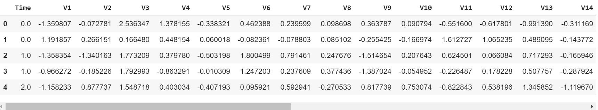

Code : Describing the Data

# Print the shape of the data

# data = data.sample(frac = 0.1, random_state = 48)

print(data.shape)

print(data.describe())

Output :

(284807, 31)

Time V1 ... Amount Class

count 284807.000000 2.848070e+05 ... 284807.000000 284807.000000

mean 94813.859575 3.919560e-15 ... 88.349619 0.001727

std 47488.145955 1.958696e+00 ... 250.120109 0.041527

min 0.000000 -5.640751e+01 ... 0.000000 0.000000

25% 54201.500000 -9.203734e-01 ... 5.600000 0.000000

50% 84692.000000 1.810880e-02 ... 22.000000 0.000000

75% 139320.500000 1.315642e+00 ... 77.165000 0.000000

max 172792.000000 2.454930e+00 ... 25691.160000 1.000000

[8 rows x 31 columns]

Code : Imbalance in the data

Time to explain the data we are dealing with.

# Determine number of fraud cases in dataset

fraud = data[data['Class'] == 1]

valid = data[data['Class'] == 0]

outlierFraction = len(fraud)/float(len(valid))

print(outlierFraction)

print('Fraud Cases: {}'.format(len(data[data['Class'] == 1])))

print('Valid Transactions: {}'.format(len(data[data['Class'] == 0])))

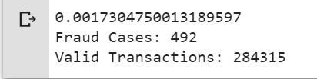

Only 0.17% fraudulent transaction out all the transactions. The data is highly Unbalanced. Lets first apply our models without balancing it and if we don’t get a good accuracy then we can find a way to balance this dataset. But first, let’s implement the model without it and will balance the data only if needed.

Code : Print the amount details for Fraudulent Transaction

fraud = data[data['Class'] == 1]

valid = data[data['Class'] == 0]

outlierFraction = len(fraud)/float(len(valid))

print(outlierFraction)

print('Fraud Cases: {}'.format(len(data[data['Class'] == 1])))

print('Valid Transactions: {}'.format(len(data[data['Class'] == 0])))



Output :

Amount details of the fraudulent transaction

count 492.000000

mean 122.211321

std 256.683288

min 0.000000

25% 1.000000

50% 9.250000

75% 105.890000

max 2125.870000

Name: Amount, dtype: float64

Code : Print the amount details for Normal Transaction

print(“details of valid transaction”)

valid.Amount.describe()

Output :

Amount details of valid transaction

count 284315.000000

mean 88.291022

std 250.105092

min 0.000000

25% 5.650000

50% 22.000000

75% 77.050000

max 25691.160000

Name: Amount, dtype: float64

As we can clearly notice from this, the average Money transaction for the fraudulent ones is more. This makes this problem crucial to deal with.

Code : Plotting the Correlation Matrix

The correlation matrix graphically gives us an idea of how features correlate with each other and can help us predict what are the features that are most relevant for the prediction.

# Correlation matrix

corrmat = data.corr()

fig = plt.figure(figsize = (12, 9))

sns.heatmap(corrmat, vmax = .8, square = True)

plt.show()

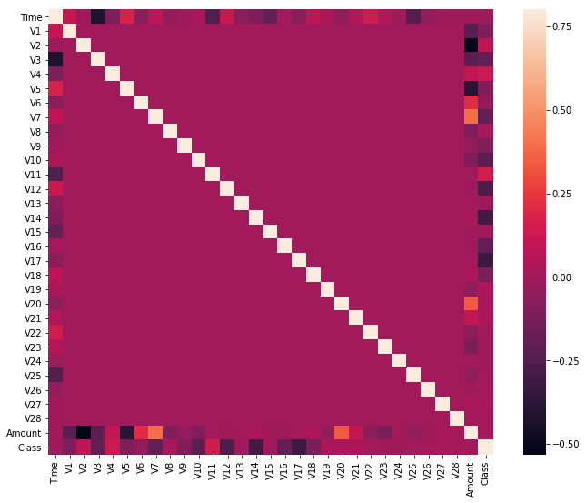

In the HeatMap we can clearly see that most of the features do not correlate to other features but there are some features that either has a positive or a negative correlation with each other. For example, V2 and V5 are highly negatively correlated with the feature called Amount. We also see some correlation with V20 and Amount. This gives us a deeper understanding of the Data available to us.

Code : Separating the X and the Y values

Dividing the data into inputs parameters and outputs value format

# dividing the X and the Y from the dataset

X = data.drop(['Class'], axis = 1)

Y = data["Class"]

print(X.shape)

print(Y.shape)

# getting just the values for the sake of processing

# (its a numpy array with no columns)

xData = X.values

yData = Y.values

Output :

(284807, 30)

(284807, )

Training and Testing Data Bifurcation

We will be dividing the dataset into two main groups. One for training the model and the other for Testing our trained model’s performance.

# Using Scikit-learn to split data into training and testing sets

from sklearn.model_selection import train_test_split

# Split the data into training and testing sets

xTrain, xTest, yTrain, yTest = train_test_split(

xData, yData, test_size = 0.2, random_state = 42)

Code : Building a Random Forest Model using scikit learn

# Building the Random Forest Classifier (RANDOM FOREST)

from sklearn.ensemble import RandomForestClassifier

# random forest model creation

rfc = RandomForestClassifier()

rfc.fit(xTrain, yTrain)

# predictions

yPred = rfc.predict(xTest)

Code : Building all kinds of evaluating parameters

# Evaluating the classifier

# printing every score of the classifier

# scoring in anything

from sklearn.metrics import classification_report, accuracy_score

from sklearn.metrics import precision_score, recall_score

from sklearn.metrics import f1_score, matthews_corrcoef

from sklearn.metrics import confusion_matrix

n_outliers = len(fraud)

n_errors = (yPred != yTest).sum()

print("The model used is Random Forest classifier")

acc = accuracy_score(yTest, yPred)

print("The accuracy is {}".format(acc))

prec = precision_score(yTest, yPred)

print("The precision is {}".format(prec))

rec = recall_score(yTest, yPred)

print("The recall is {}".format(rec))

f1 = f1_score(yTest, yPred)

print("The F1-Score is {}".format(f1))

MCC = matthews_corrcoef(yTest, yPred)

print("The Matthews correlation coefficient is{}".format(MCC))

Output :

The model used is Random Forest classifier

The accuracy is 0.9995611109160493

The precision is 0.9866666666666667

The recall is 0.7551020408163265

The F1-Score is 0.8554913294797689

The Matthews correlation coefficient is0.8629589216367891

Code : Visualizing the Confusion Matrix

# printing the confusion matrix

LABELS = ['Normal', 'Fraud']

conf_matrix = confusion_matrix(yTest, yPred)

plt.figure(figsize =(12, 12))

sns.heatmap(conf_matrix, xticklabels = LABELS,

yticklabels = LABELS, annot = True, fmt ="d");

plt.title("Confusion matrix")

plt.ylabel('True class')

plt.xlabel('Predicted class')

plt.show()

Output :

